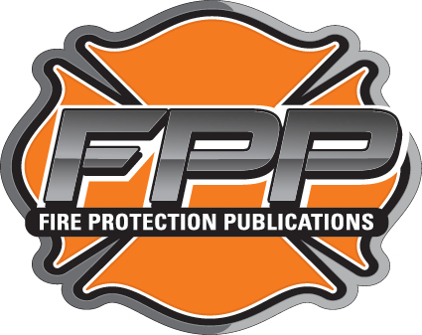

PERMISSION FORM FOR
FIRE PROTECTION PUBLICATIONS USE
OF COPYRIGHTED MATERIAL

Name: |  | Joe Smith
 |  | (Name of copyright owner or authorized agent)
grants permission to Fire Protection Publications to use, reproduce, publish, perform, display, adapt, modify, distribute, and/or transmit, in whole, or in part, or in composite, in any medium, including, but not limited to, printed, electronic or multi media format, the attached photo(s), illustration(s), figure(s), article(s), text, or other items in and for the worldwide publication and distribution of (specify manual or
text) | Essentials of Fire Fighting 7th
 |  |  | (Fill in Manual Title [Example: Essentials of Fire Fighting or Pumping Apparatus] or write GENERAL USE)
and any associated products (including multi-media products) and/or teaching materials and for all
editions and all future revisions thereof.

Please provide desired courtesy line: | Courtesy of Joe Smith.

By signing below, I affirm that I am authorized to grant the permission(s) herein granted for the item(s) described above.

Authorized by: | Joe Smith, Training Officer
 | (Print Name and Title)

Signature: | Joe Smith | Date: | 12/10/15

Organization: | Cornville-Page Springs Fire Dept.

Address: | 123 Page Springs Road

City: | Cornville | State: | AZ | Zip: | 86325

Phone: | (620) 555-1234 | Fax: | (620) 555-2345

Email: | jsmith@cpsfd.gov

By signing below, I further affirm that the above granted permission shall extend to any other Fire Protection Publication texts, manuals, and/or teaching materials and associated products (including multi media) and all editions and future revisions thereof.

Signature: | Joe Smith | Date: | 12/10/15

Please complete and return this form to: | Sam Jones
(Lead Senior Editor or Point of Contact [POC])
Fire Protection Publications
930 N. Willis
Stillwater, OK 74078
(405) 744-4111
 | POC Phone #: | (405) 744-1234
 | POC E-mail: | sjones@osufpp.edu

You may choose to FAX this form to: (405) 744-4112
12/10/2015

